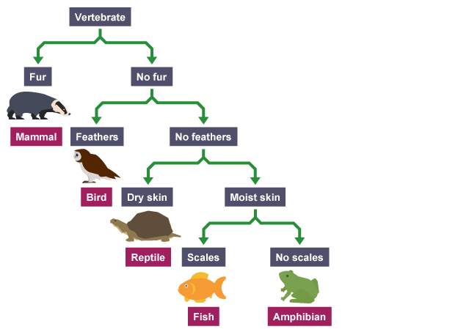
Year 7 Classification Test Revision

- Look at the dichotomous key for Vertebrates.
  - What features are used to separate the organisms?
  - What features does a bird have?
  - What features does a fish have?

- Draw a branched dichotomous key for these animals.

- Rabbit
- Dog
- Cat
- Fish
- Guinea pig
- Bird
- Mouse
- Horse

- Write a tabular key for the branched key you drew in question 2.

- What are the three kingdoms of living things we have learnt about? Name two common features of organisms in each group.

- Redraw, extend and complete the table to show the nine phyla we have learnt about in Kingdom Animalia.
Phylum | Characteristics | Example
Chordates | Have a spinal cord and backbone. | Monkey

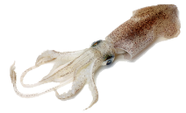
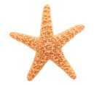
- For each of the animals below, name its phylum and explain your choice.

  - Starfish

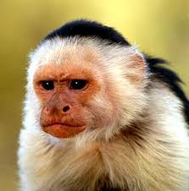
  - Monkey

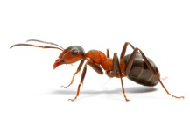
  - Ant

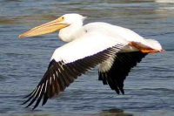
  - Pelican

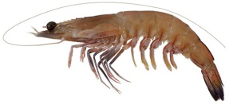
  - Prawn

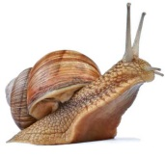
  - Snail

  - Squid

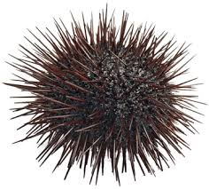
  - Sea urchin

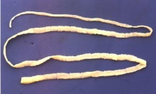
  - Tape worm

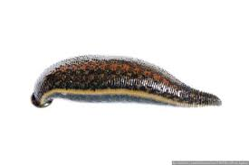
  - Leech
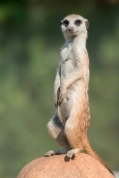

  - Meerkat
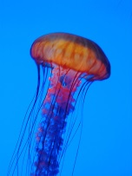

  - Jellyfish

- Redraw, extend and complete the table to show the 5 classes of chordates.
Class | Characteristics | Example
- For each of the chordates below, name its class and explain your choice.

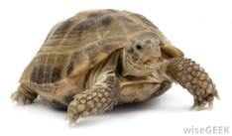
  - Turtle

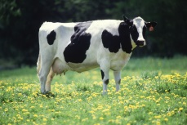
  - Cow

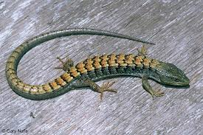
  - Lizard

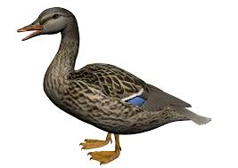
  - Duck

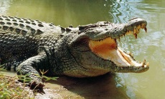
  - Crocodile

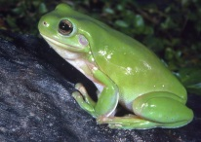
  - Tree Frog

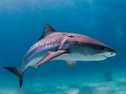
  - Shark
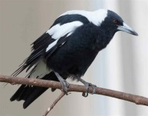

  - Magpie

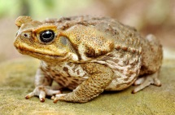
  - Cane toad

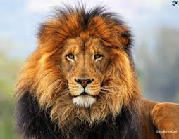
  - Lion

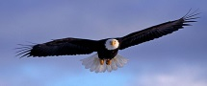
  - Eagle

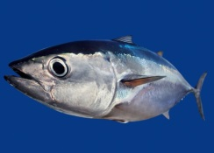
  - Tuna

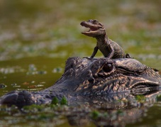
  - Alligator

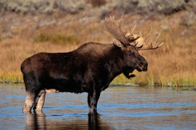
  - Moose

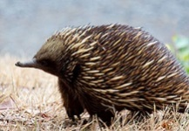
  - Echidna
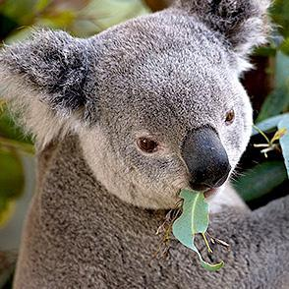

  - Koala

- Redraw, extend and complete the table to show the 4 classes of arthropods.
Class | Characteristics | Example

- For each of the arthropods below, name its class and explain your choice.

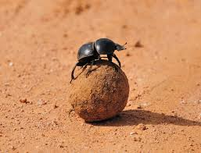
  - Dung beetle

  - Spider
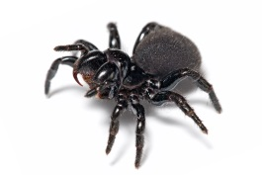

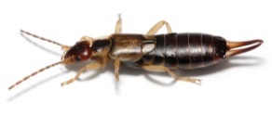
  - Earwig

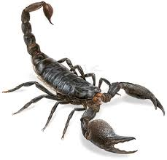
  - Scorpion

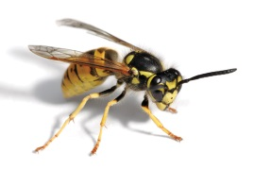
  - Wasp

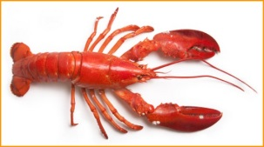
  - Lobster

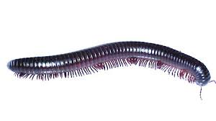
  - Millipede

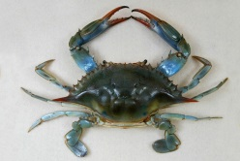
  - Crab

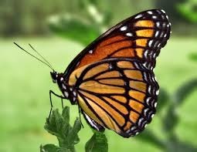
  - Butterfly

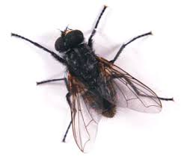
  - Fly

